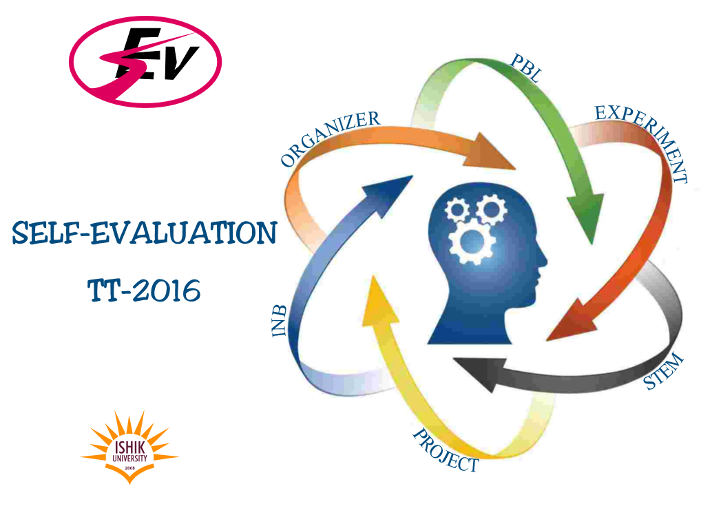


NAME: ___________________________________ CLASS: ________________DEPARTMENT: _____________________
READING RECORD
 | Name of the Book | Level | Total Page | Date
- 2
 | TOTAL
It is time to read!.
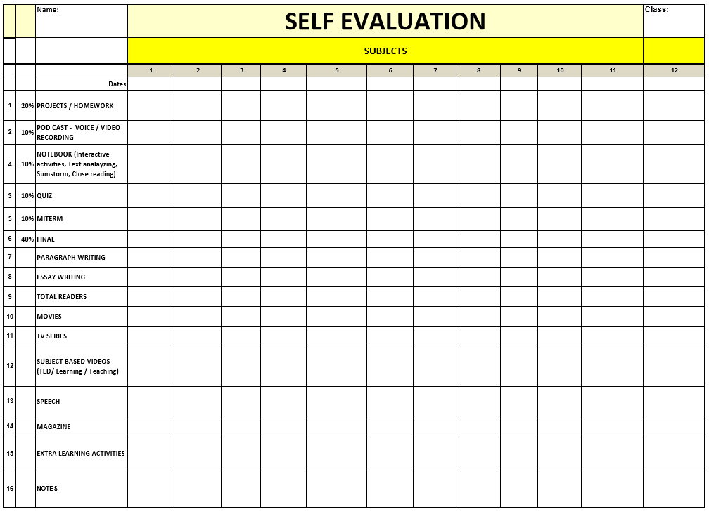

TEACHER PROFESSIONAL DEVELOPMENT CENTER

‘Active Learning and Teaching’

- 30/10 Days Challenges
- Active Learning
- Brainstorming
- Class Projects
- Classroom Design
- Classroom Language
- Classroom Rules
- Critical Thinking
- Debate
- Diary Writing
- Dictation
- Dictionary Work
- Exams
- First Day of Class
- Flash Cards
- Flowcharts
- Free Writing Notebook
- Games and Activities (Using Games for Learning and Assessment)
- Group Dynamics Techniques
- Group Projects
- Guidance Education
- Handwriting - Drawing
- Interactive Desk
- Interactive Notebook
- Interactive Student 3 D Projects
- Interactive Teaching Materials
- Letter Writing
- Magazine Preparation
- Material Development
- Movie (using movie in class)
- Music
- Note Taking
- Organizers
- PBL (Project Based Learning)
- Picture Analyzing
- Pinterest, Web Pages/Blogs, Youtube, TED, Prager University; Scishow,…. )
- Podcast Recording
- Poster Preparation
- Post-it
- Power Point
- Problem Based Education
- Project Based Education
- Projects- Group
- Projects- Individual
- Put Idea into Picture
- Quizzes
- Reading (Extensive)
- Reports Writing
- Role Play
- Self-Evaluation
- Service Learning / Projects
- Social Media Projects (Twitter, Instagram, Facebook, ………………….….)
- Social Medias/Technology
- Song
- Speech
- Spelling Bee
- STEM Projects
- Story Telling
- Summarizing
- Summarizing (How to Summarize an Article / Text)
- Sumstorm Notebook
- Syllabus Writing
- Teaching Experiences
- Text Analyzing
- Text Mapping
- Thinking Aloud
- Using Social Medias/Technology (Twitter, Facebook, Googleplus, Google Driver, Google Classroom
- Video Lesson
- Video Recording Analyzing (Micro Teaching)
- Video Recording Analyzing (Sample Lessons)
- Vocabulary Teaching
- Web Page Design
- Whole Power Teaching
- Worksheet
- Writing (Process, Classification, Definition, Cause and Effect,…)

