
examine

MATH NEWSPAPER

Newspaper Editor : Merve Nur Turhan 25 ,October, 2013 No: 1
: ___________________Tangram_____________________
You may have heard of tangram game before. We can say that the game comes from the Far East. The Far Eastern people love this game very much. The game becomes 7 pieces when the pieces are broken apart. We can make a lot of shapes by putting the pieces side by side. The Far Eastern people made lots of interesting shapes before the game was so popular. Then the game became popular. We use five pieces of triangles and a piece of parallelogram and a shape of square for this game. We can have analytical thinking thanks to this game...

__________________Interesting Numbers_________________
It is very interesting for math state. We count 1,2,3,4,5,6,7,9. We don’t write 8. We dash this number with nine’s floors.
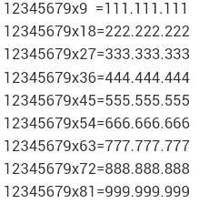
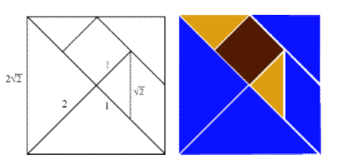
12345679 x 9.1 = 111.111.111
12345679 x 9.2=222.222.222 …
It has a magnificent conclusion…

