October NEWSPAPER
Newspaper Editor: Barham Hasan . 22/October/2013 No: 1
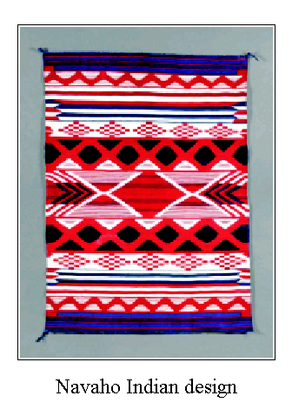
HEADLINE : ORNAMENTATION
Anyone who has visited New Mexico has seen the beautiful blankets still woven by the local Indians. These blankets and other objects of Indian art throughout North America have an assortment of geometrical patterns and themes. Navajo pottery, for example, exhibits opposed sets of isosceles triangles, line bordering dots, hooked spirals, double spirals, vertical and horizontal lines, and stepped figures.
________________________________________________________________________________________________________________________________________________________________________________________________________________________________________________________________________________________________________________________________________________________________________________________________________________________________________________________________________________

HEADLINE: THE WINTER OLYMPICS HEADLINE: SHORT STORY
In 20 years, 20 years from now there’ll be this beautiful woman named Kristin. She’ll want to visit the moon. She’s gonna want to visit the moon. She’ll want to go there for spiritual reasons. In fact, she’ll want to meditate on the moon for 10 days.
Unfortunately, in the future, rockets are still gonna be expensive. They’re super expensive now and they’re still gonna be expensive in the future. So she’llneed to earn a great living to save money to buy an expensive rocket. But her jobwon’t pay her much money. She won’t have a great job. She won’t have much money. And so she’ll start her own business. She’ll start a new business. She’ll decide to cater to penguins. She’ll sell fish to penguins. That’s gonna be her business. And it will be a successful business because penguins will be super rich and they’re gonna give her a lot of money because they love fish. And eventually she’ll buy her big powerful rocket. And she’ll go to the edge of space and she’ll continue and go all the way to the moon. But she’s not gonna go alone. She’s gonna go with her favorite penguin Bob. Bob will accompany Kristin. He’s gonna accompany her all the way to the moon. Together Kristin and Bob the penguin will go to the moon and they’ll meditate together on the moon for 10 days. They’ll be peaceful, calm and happy.

Since 1924, the winter Olympics has been an international event. Now these activities are seen by millions on television. Men and women from distant cities and countries participate in this competition. They all wish to be winners. They ski downhill amidst pretty scenery. Figure skaters spin to victory. Skill will make the difference. Some will finish with a silver medal, some with a gold. But all with win our hearts and infinite respect.
______________________________________________
______________________________________________ ______________________________________________



