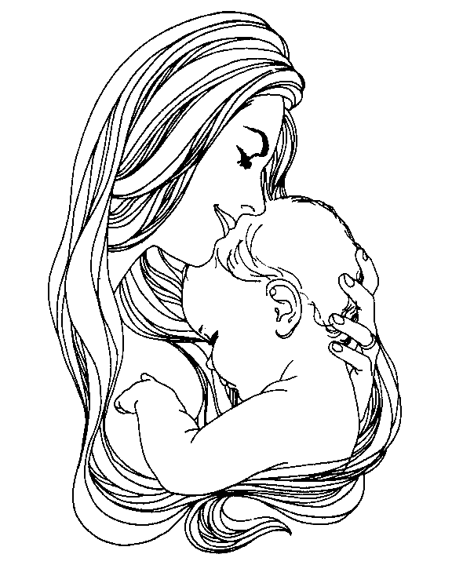

Mother

Mother mother is right here

Mother mother is in my ear

Mother mother is right there

Mother mother is everywhere

Mother mother never sleeps

Mother mother always weeps

Mother mother said to me

I am here I'll always be

Mother comes and mother goes

Mothers out to buy me clothes

Mother and I are very close

That's why I love her the most

Mother mother never leaves

In God we believe

Mothers love will always flow

Mother mother will never go

Kimoni White
