CLASSROOM
OBSERVATION

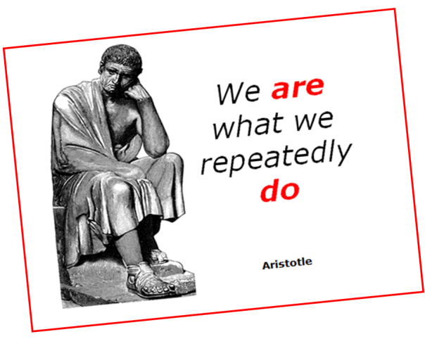

What Will You Look For?
These observation assignments are designed to help you have a more productive learning or teaching experience when you do your 25-30 hours of observations. You will have several observation assignments to complete during your field work.
You should pay attention the selected topics below:

- Assignments
- Developmental flow of the Lesson
- Discipline
- External factors
- Grading
- Interpersonal Interactions (
- Map of the room
- Type of Interaction
- Use of Chalkboard/Smartboard/LCD projector
- Use of Learning/Teaching Aids
- Use of Questions
- Use of Textbook
- Students behavior (Active and Passive)
- Seating system.
- Using activities.

7… Map of the Room:
- Draw a map of the classroom.
- What kind of a learning environment is it?
- What "signs" do you see in the room that science/chemistry/maths.. is taught & learned here? comfortable learning environment? seating arrangements?
- What does what you see in the room tell you about what usually happens there?
4… External Factors:
- How many interruptions during the class period? For what? By whom?
- How does the teacher deal with these unasked interruptions?
3… Discipline
- What things does the teacher say or do to establish the "tone" of the classroom?
- What factors contribute to making the classroom an effective learning environment? If an "event" occurs -- how did it develop? What did the student(s) do? What did the teacher do? Not do?
11…. Use of Questions:
- What types of questions were asked? By whom? Who responds? How often?
- What happens to the responses of the students? Responses of the teacher?
Assignments:
- When given? What? Why? What happens to it afterward? Clear purpose?
- How does it relate to enhancing learning?
- Student reactions?
Grading:
- How is it handled/controlled/carried out? Student reactions?
- How does the teacher feel about his/her grading procedures?

Interpersonal Interactions:
- What is the "flow" of classroom communication? Primarily from teacher to students? How much?
- What is the role of the teacher in this lesson? (i.e., source of all the information? facilitator? or what?) What evidence is there to indicate the degree to which students are actively involved in learning?
Use of Textbook:
- Does it "dominate" what happens in class?
- How is it used? For what purposes? How often? How helpful is it?
- Do students appear to like it?
- Does the teacher share strategies for success with students?
Use of Learning Aids
- Does the teacher use audio-visual materials?
demonstration materials?
models?
charts/maps?
- How effective do the materials seem to be?
Use of Chalkboard/Smartboard/LCD projector:
- Legible?
- visible?
- make sense?
- What might have been done differently?
- Handouts, Test, etc. How helpful are they? How do they contribute to learning? Legible/clear? Understandable? (get copies for possible future analysis)

Developmental flow of the Lesson:
What components are present, and what is their sequence of occurrence? For example:
- lesson usually begins with some sort of introduction, the aim of which frequently is to motivate, or to "grab" the students' interest.
- early in the lesson, one often attempts to provide a sense of direction; aims of the lesson; focus for what will follow; objectives.
- at end of activities, does the teacher summarize (overall summary)?
- does the teacher do something to find out how well students have learned the material of the lesson? (lesson "appraisal")
- assignments and/or "enrichments" are often used to round out/improve the lesson; some teachers use some sort of a "generalizing experience" which helps students to broaden their understanding of a concept or skill.

Classroom Observation Worksheet

Instructions
Please provide the presenter with a constructive evaluation of the program. Each question is rated on a scale of 1-5. Comments are appreciated. Please consider each item carefully and assign the highest scores only for unusually effective performance.

Highest Satisfactory Lowest Not Applicable/valid
5 4 3 2 1 NA

T1 T2 T3 T4 T5 T6
Lesson
Organization
- Begins class on time in an orderly, organized fashion (style, technique)
- Appears well-prepared for class
- Clearly states the goal or objective for the period
- Defines relationship or this lesson to previous lessons
- Presents topics with a logical sequence
- Paces lesson appropriately
- Summarizes major points of lesson
- Respond to problems raised during lesson
- Relates today’s lesson to future lessons
Presentation
- Speaks audibly and clearly, and without distracting speech characteristics
- Talks to the students, not the board or windows
- Explains ideas with clarity
- Uses a variety of appropriate techniques to maintain student interest and attentiveness (e.g., maintenance of eye contact, etc.)
- Listens to student questions & comments
- Projects nonverbal gestures consistent with intentions
- Defines unfamiliar terms, concepts, and principles
- Presents examples to clarify points
- Relates new ideas to familiar concepts
- Restates important ideas at appropriate times
- Varies explanations for complex and difficult material
- Uses humor appropriately to strengthen holding & interest

Instructor-Student Interactions
- Knows students' names and responds to them as individuals
- Encourages student questions
- Encourages student discussion
- Maintains student attention
- Gives satisfactory explanation
- Paces lesson to allow time for note taking
- Encourages students to answer difficult questions
- Treats class members equitably and respectfully
- Restates questions and answers when necessary
- Demonstrates effective listening behaviors
Active learning (labs, activities, etc.)
- Clearly explains directions or procedures
- Clearly explains the goal of the activity
- Has readily available materials and equipment necessary to complete the activity
- Allows opportunity for individual expression
- Provides practice time
- Gives prompt/quick attention to individual problems
- Provides individuals constructive/helpful verbal feedback
- Allows sufficient time for completion
- Provides enough demonstrations
- Demonstrations are clearly visible to all students
- Provides opportunities for dialogue about the activity with peers and/or the instructor
What were the instructors’ major strengths as demonstrated in your observation?

Minute by Minute Classroom Observation
Teacher: 1 Subject: _______

Teacher: 2 Subject: _______
Minute Implementation

